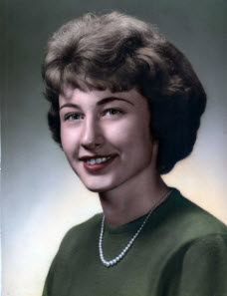

**Suzanne Kay (Wolfe) Mettle**

**Photo taken about 1960**



**Greg Rigelman, Renee Mettle, Diane (Mettle) Polczynski,**

**Suzanne (Wolfe) Mettle, Dennis Mettle**

**Photo taken 2 May 2009**